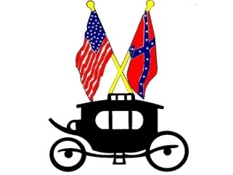

Town of Middletown
7875 Church Street
Middletown, Virginia 22645
(540) 869-2226 ♦ Fax (540) 869-4306
Gateway to Cedar Creek and Belle Grove National Historical Park

PARK RESERVATION REQUEST

Person Requesting:______________________________ Date of Request:_______________

Mailing Address:______________________________________________________________

Home Telephone:_______________________ Work Telephone:____________________

Email Address:_________________________

Event: ________________________________ Date Event: ______________________

Beginning Time: ________________________ End Time:__________________________

Number of Attendee’s ___________________

Upon signing this request, I agree to pay a $50.00 non-refundable Park Maintenance Fee (with the exception of verified non-profit organizations) and accept full responsibility for any damage to park facilities during this event. I also acknowledge receipt and under-standing of the applicable Park Regulations attached to this request.

___________________________________

^{(Applicant’s Signature)}

FOR OFFICE USE ONLY

DATE RECEIVED _______________________ RECEIVED BY _____________________

AFTER EVENT PARK CONDITION REPORT:____________________________________ ______________________________________________________________________________ ______________________________________________________________________________ ______________________________________________________________________________

